Social Studies 6 Name _________________________

Early Middle Ages Date __________________________

The Early Middle Ages

The period known as the Middle Ages lasted from about 500 to 1500AD. It began as the Roman Empire was conquered by groups of people from an area near what is now Germany.

By the mid-500s, five of these groups controlled most of Europe:
- The Visigoths, who had conquered Rome, held most of the Iberian Peninsula ( now Spain).
- The Vandals controlled North Africa and the large Mediterranean islands.
- The Ostrogoths had taken over most of Italy and the western Balkans.
- The Saxons conquered the southern part of what is now England.
- The Franks controlled most of Gaul, now France and western Germany.

They did not govern these large areas as single countries. Each tribe had many leaders, called chieftains. Each chieftain ruled only as much land as his warriors could defend. The Germanic tribes spread fear and destruction at first. Gradually, however, they learned the ways of their more civilized neighbors. Chieftains often imitated Roman forms of government.

Charlemagne
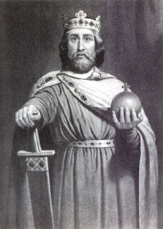
The man who came closest to recreating the Roman Empire during the early Middle Ages looked like he was born to be a king. In a time when most warriors were a little over 5 feet tall, he was 6 feet 4 inches. His broad shoulders and straight posture seemed to show his strong will. This king's name was Charlemagne, which meant "Charles the Great." In 768AD he became king of the Franks, the tribe that gave France its name. Later, Charlemagne conquered large parts of Germany and Italy.
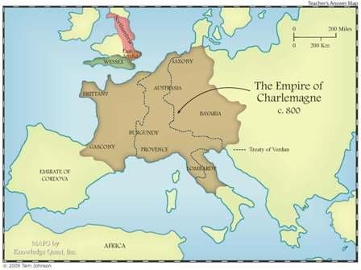

Charlemagne had close ties with the leader of the Roman Catholic Church, the Pope. Charlemagne had helped popes defend Rome. In 800AD Pope Leo III crowned Charlemagne as the head of lands later called the Holy Roman Empire and gave him the title of "Augustus."
In Charlemagne's time, very few people could read and write. Most of those who could were priests or scholars, who worked for kings or nobles. Charlemagne respected learning. He encouraged scholars from all over Europe to come to his court. He set up schools for his nobles and their sons.
He urged priests throughout his empire to teach "all those who with God's help are able to learn." Charlemagne had a strong desire to rule fairly. He dictated many letters to his nobles, giving instructions about government, law, religion, education, and trade. He sent royal messengers to find out how well his government was working. Charlemagne also traveled around his lands to make sure his people were treated justly.
Once or twice a year Charlemagne met with his major officials. Spring meetings called the Fields of May became famous. They were festivals for Charlemagne's followers. In a pasture filled with flowers, Charlemagne set up a small city of tents and consulted with his officials. In his concern for strong, wise government, Charlemagne was like Augustus, the emperor of Rome. Charlemagne's peaceful rule was the high point of the early Middle Ages.
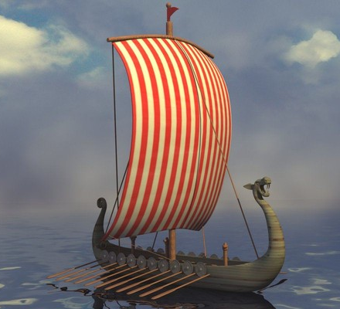
The Vikings
Before Charlemagne's death in 814AD, fierce warriors called Vikings threatened the security of his empire. The Vikings came from the north, from Norway, Sweden, and Denmark. At first the Vikings were interested mostly in plunder, or goods taken by force. They sailed along coasts and far up European rivers in their dragon-headed ships. Wearing leather helmets, the Vikings carried double-edged swords and round shields. These sailors were so tough that they slept on the open decks of their ships even in the freezing storms of the North Sea.

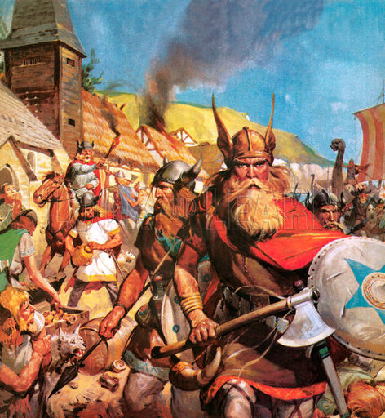
When the Vikings arrived at a town, they usually attacked its church first. They took religious objects made of gold and silver. Then they raided the homes of the townspeople and farms. By the middle of the tenth century, raids became fewer as the Vikings developed other interests. Some Vikings became traders, sailing as far as Constantinople and what is today Russia. They contributed knowledge of trade routes and sailing to the people they met. Some Vikings were explorers. They made the journey to North America about 500 years before Christopher Columbus did. Other Vikings became colonists, setting up farms and towns in countries they had attacked. Many of these colonists became Christians. The Vikings, like the Germanic tribes before them, became part of Europe's settled communities. The Vikings both enriched and were absorbed by the lands they raided.

Write one of the bold, underlined words from Write one of the bold, underlined words from the reading next to its synonym or definition: the reading next to its synonym or definition
Synonym/Definition | Word from reading
1. copying
2. settlers
3. said out loud
4.stolen goods
5. wide
Synonym/Definition | Word from reading
6. stance or attitude
7. fairly
8. tribal leader
9. insisted on
10. discussed

11. How many years ago was Charlemagne
crowned as the Holy Roman Emperor ? _______

12. The Middle Ages lasted about ______ years.
a. 500 b.1000 c. 1500 d. 2000

13. Which tribe controlled North Africa?
- Franks b. Saxons c. Vandals

14. Charlemagne was the king of the ______.
- Franks b. Saxons c. Vandals

15. Use the map and scale of miles to complete
this sentence:
From east to west, Charlemagne’s empire was
about ___ miles wide. a. 200 b. 400 c. 600

16.
Place the following items in one section of the Venn Diagram. Write the letters, not the phrases.

A. attacked in the 4th and 5th centuries
B. attacked in the 9th and 10th centuries
C. attacked Europe
D. usually rode ships into battle
E. usually rode horses into battle
F. were feared as fierce warriors
G. some members settled and stayed in the
areas they attacked
H. came from northern Europe
I. came from Asia and Eastern Europe

Vikings
Barbarians

